**HEALTHCARE GUIDANCE**

Anand Kumar

Internship ID STU629f05287316d1654588712

**Abstract: (Problem Definition)**

**We are working on a HealthCare Guidance Website for health care sector. Everyone wants appointment with a good doctor on time but it’s also a difficult task for the patients to get a appointment on required time with a good doctor. To bridge the gap between this we decided to build a healthcare and guidance website. Healthcare Guider Website is basically useful to any person who wants to save time and take doctors appointment online mode and also opt for online consulation through video chat and voice call. Patients can also make online payments to doctor through there UPI ID or net banking .**

**Introduction:**

**Healthcare Guider Website is basically useful to any person who wants to save time and take doctors appointment online mode and also opt for online conciliation through video chat and voice call. After getting appointment from the doctor the conformation email will be provided to both patients and the doctor, inside that email all the details of patients will be provided to the doctor with appointment timing and a meeting joining link of Google meet and the details of doctors will be sent to the patients with appointment timing and Google meet link for the meeting. All the appointments of the user will be stored in appointment table and is fetched to website in Appointments menu. User can also cancel and change appointment. Patients can also make online payments to doctor through there UPI ID or net banking .**

**All the data of patients doctors and patients appointment will be stored in different tables of database and can be fetched on the website.**

**To use and access all the features of website user have to login through his/her email id. And new user can Signup through their email id .Full email validation will be used ,no email registered before will be used to signup, they can only login not signup full account security will be given to every user. All the user data like name ,email, phone number , age, gender, date of birth will be stored in user table inside the database made inside PhpMyadmin. The Database is connected to the website using php as a backend language. Doctors will also be provided with login email and password which will be created by the website admin. Using that email doctors can login and see their patients details.**

**This project is mainly for the any user who want some medical and healthcare related services. 24 hours we have doctors availability with every specialization mainly what a patients have to do is just book an appointment on available time slot and get confirmed appointment. Patients can use the app as a appointment booking app and get an appointment easily. They can also use this project as guidance for disease to get knowledge about the symptoms, medicine and a proper cure. Doctors and trained medical professionals can also use this project to get patients online and help them furthermore they can get their fees online without any delay. We are providing a fully virtual mode for cost effective appointment and treatment for those in need.**

**Related study:**

**Example of Existing Solution:**

**Apollo24/7**

**Comparison with Existing Solution:**

|  |  |  |
| --- | --- | --- |
| **features** | **HEALTHCARE GUIDANCE** | **APOLLO247** |
| **Reputed doctors** |  |  |
| **Anytime doctors availability** |  |  |
| **Full online services available** |  |  |
| **Instant appointment** |  |  |

**The main feature of this app is that it provides a good platform to create a clear communication between doctors and patients. All the patients have free access to chat with the doctors they have taken appointment. Taking appointment through our website is easy and time saving. The website UI is fully user friendly and easy to use. It fetches data very fast reload time is not so disturbing. All this features are mainly not available in the available website.**

**Proposed System(Solution):**

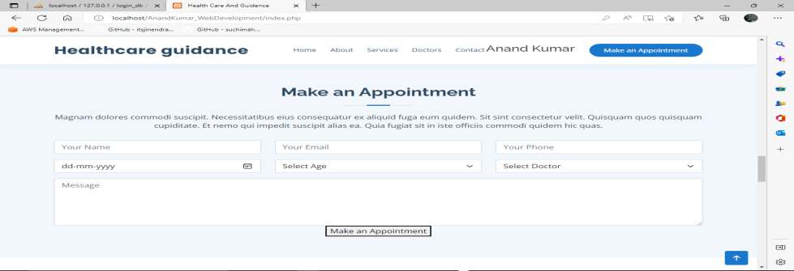

**We provide you appointments from good quality doctors from advance hospitals present in India at very pocket friendly price.**

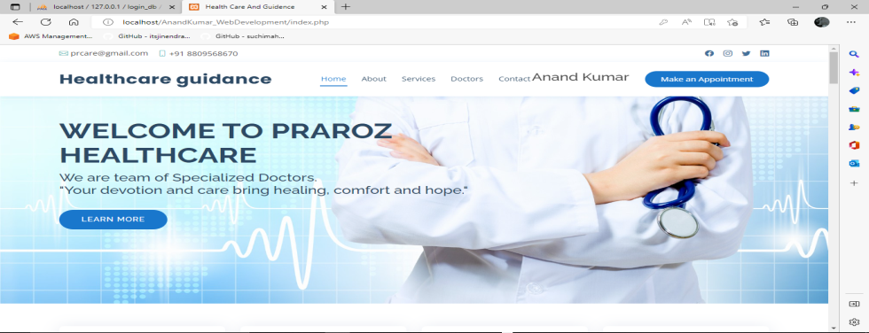

**The website UI is fully user friendly and easy to use.**

**It fetches data very fast reload time is not so disturbing**

**Limitation(Future Work):**

**We are working on adding medicine facilities to the patients for free delivery.**

**We also want to give a platform to the local medical shops to sell medicine online.**

**In future our payment and video call features will also increase.**

**And it will be more secure.**

**References:**

<https://www.w3schools.com/>

<https://getbootstrap.com/>

<https://youtube.com/>

<https://google.com/>